|  |
| --- |
| [Company name] |
| Northern Ireland Protocol (UK-EU) |
| Brexit withdrawal agreement |

|  |
| --- |
| Tejas Naik (Student no- 210221736)  12-14-2022 |

Table of Contents

1. Introduction 2

1.1 What is Northern Ireland Protocol? 2

1.2 Problem Statement 2

1.3 Why Protocol is so complicated? 3

2.0 Soft System Methodology Part I 3

2.1 Stakeholder 3

2.2 Power Matrix 4

3.0 Soft System Methodology Part II 4

3.1 Rich Picture 4

3.1 Overview 5

4.0 Software System Methodology III 6

4.1 PQR Statement and Root Definition 6

4.2 CATWOE 8

4.3 Conceptual Model 11

4.3.1 Conflict One 11

4.3.2 Conflict Two 12

5.0 Complimentary Analysis 13

5.1 PESTEL Analysis 13

6.0 Recommendation 14

6.1 Propose Changes (Conflict one) 14

6.1.1 AS IS and TO BE PROCESS MAP 15

6.1.2 Ease benefit metrics (Conflict One) 16

6.2 Recommendation (Conflict two) 17

6.2.1 Ease-Benefit Matrix (Conflict Two) 18

7.0 Reference 19

# Introduction

In 2014 election campaign former Prime Minister David Cameron promises to people that if Conservative wins the 2015 election, he will give them the right to simply choose whether UK should be part of European Union or not through EU referendum.

On June 23rd 2016, over 33 million individuals from England, Scotland, Wales, Northern Ireland, and Gibraltar have voiced their opinions on EU referendum and 52% of them opted UK to leave the European Union. The UK informed the European Council of its decision to exit the EU on March 29, 2017, in accordance with Article 50 of the Treaty on European Union. This than kickstart the process of negotiation between the UK and the EU for exit term.

After three years of rigorous negotiation between the UK and EU, UK left the European Union (EU) on the 31 January 2020. A transition period was than in place until 31 December 2020 and now a new relationship with the EU is in place. This includes the Northern Ireland Protocol.

## What is Northern Ireland Protocol?

The Protocol outlines Northern Ireland's relationship with the EU and Great Britain following Brexit. It became effective on January 1st, 2021. The Protocol ensures that products moving between Northern Ireland and Ireland are not subject to checks (and the rest of the EU). This implies that items entering Northern Ireland from the United Kingdom must be examined and/or have documentation proving they adhere to EU regulations. The Protocol is a component of the EU-UK Withdrawal Agreement, a global agreement between the UK and EU that outlines how the UK would leave the EU.

## Problem Statement

The Northern Ireland Protocol has become a major issue in post Brexit trade arrangement between UK and EU. Following are the key problems in NI protocol: -

1. Tariffs on goods entering NI: - As per protocol no customs duties shall be payable for a good brought into Northern Ireland from another part of the United Kingdom by direct transport, unless those goods are at risk of subsequently being moved into the EU, whether by itself or forming part of another good
2. Supply chain crisis: - As Goods arriving in Northern Ireland, including from Great Britain would undergo regulatory checks in accordance with EU rules.
3. Political and Economic instability for NI

## Why Protocol is so complicated?

* The problem in point one as mentioned above is it is very difficult to state which goods are at risk of entering to the EU, hence EU sees almost every good entering to the NI from the UK as risk and applies custom checks on it
* With more custom checks on Irish sea, supply chain has hit new low and is affecting NI’s economy harder.
* Local political party in NI sees this protocol as a big problem and already want to get rid of it as it puts NI’s future within UK at risk.

# 2.0 Soft System Methodology Part I

## 2.1 Stakeholder

* Prime Minister office (UK)
* European President office
* Department of International Trade
* Department of foreign and commonwealth
* Executive Office (NI)
* Department of foreign Affair (Republic of Ireland)
* The UK-EU Joint Committee,
* European commission chief negotiator and
* The Members of European Parliament (MEP)
* The Member of House of Commons
* The Members of House of Lords

## 2.2 Power Matrix

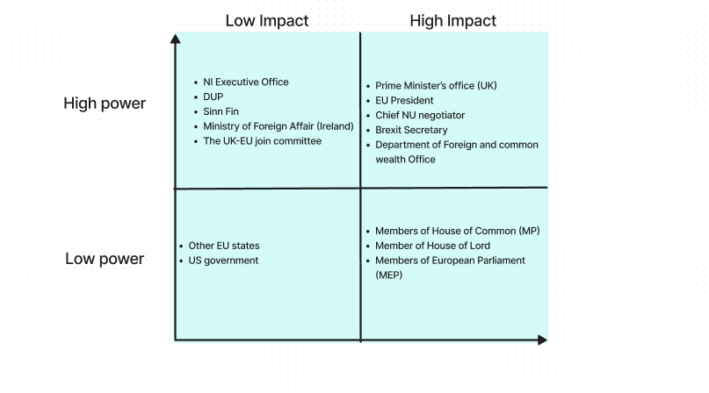

Fig 2.2 Power Matrix for Stakeholders

# Soft System Methodology Part II

## Rich Picture

In order to examine, acknowledge, and characterize a scenario and to represent it through diagrams in order to develop a preliminary mental model, one can use a rich picture. This can help to start a conversation and reach a broad, common understanding of the problem.

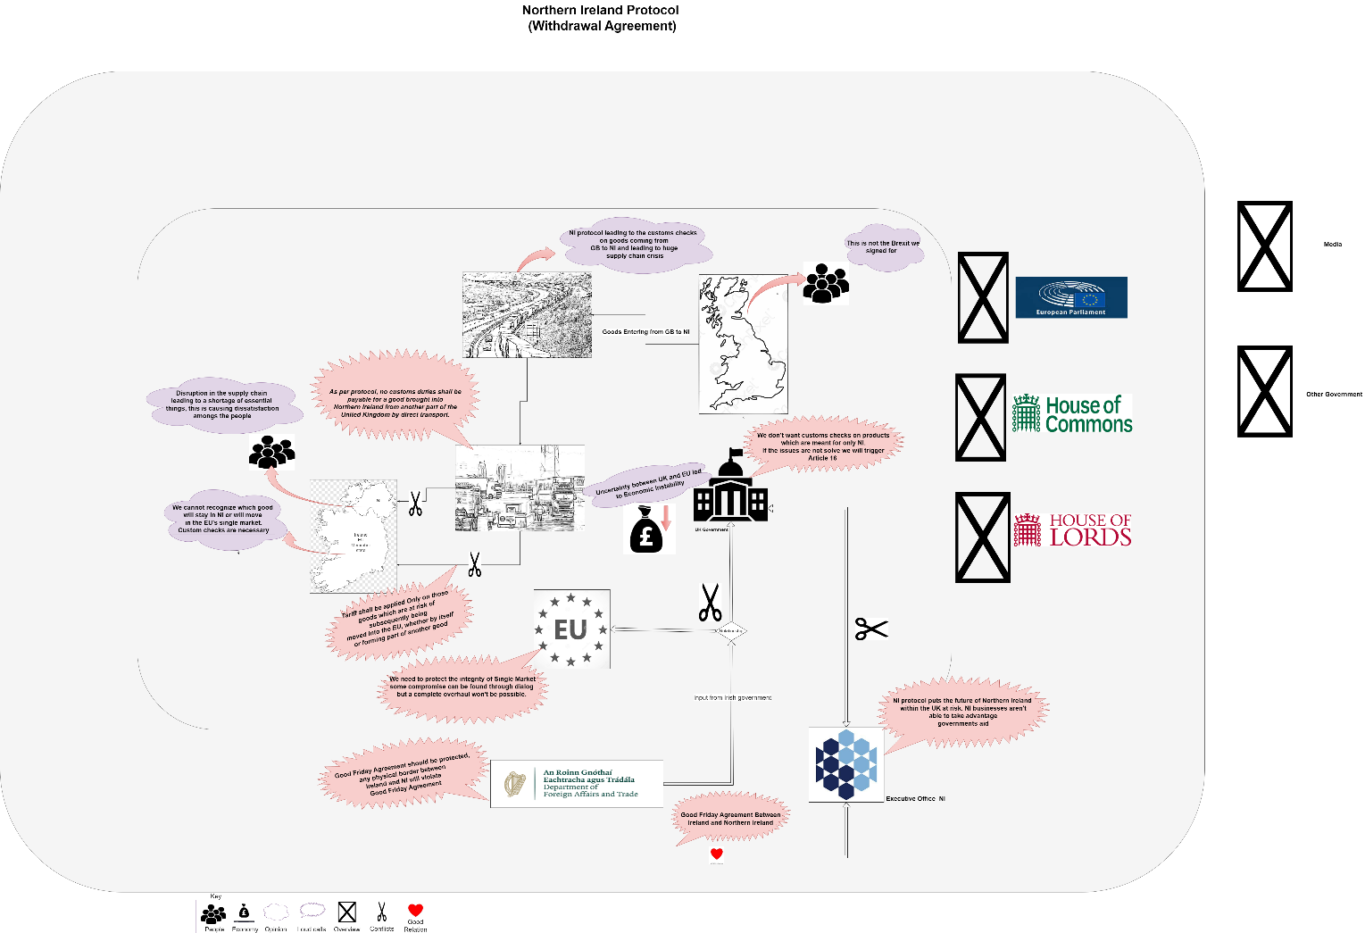

*Fig 3.1 Rich Picture on Northern Ireland Protocol*

## 3.1 Overview

Northern Ireland Protocol has become huge Issue for UK and EU, as you can see in above diagram, goods entering from Great Britain to NI has huge que of trucks waiting to enter Northern Ireland. This leading to huge Supply chain crisis and disrupting trade flow between Great Britain and Northern Ireland. People of Northern Ireland are facing shortage daily essential due to supply chain issue. One of the major reasons for trade disruption between GB and NI is EU’s custom check and goods fulfilling SPS requirement.

As per the protocol no customs duties shall be payable for a good brought into Northern Ireland from another part of the United Kingdom by direct transport, only those goods who are at risk of subsequently being moved into the EU, whether by itself or forming part of another good shall be examine for EU custom checks and SPS clearance.

In reality the story is different, EU sees all the goods which are entering into Norther Ireland as subsequent risk of moving it into EU’s single market via Northern Ireland. This leading to fulfilling requirement of EU custom check and SPS for almost all the goods coming to NI through Irish sea and does causing supply chain delay.

After the transition period UK left the EU’s single market and EU’ customs union but due to nature of Good Friday agreement between Ireland and Great Britain, NI and ROI cannot have physical border so even if the UK is not a part of EU’s single market and customs union Northern Ireland has become defacto between UK and EU so it does follow EU’s single market and Custom union check rules.

For EU, integrity of its single market is the important as they don’t want any business to take advantage of 300 miles open border between NI and Republic of Ireland and injects goods illegally. UK on the other sides sees NI protocol is not working in the way it has to be. Northern Ireland protocol has also created political instability within Northern Ireland Assembly as DUP (Democratic Unionist party) sees NI protocol as a threat.

Members of European Parliament and Members of House of House of commons and House of Lords will play vital role if and when any revised deal comes into table. US government wants Good Friday agreement will be treated with outmost respect.

# 4.0 Software System Methodology III

## 4.1 PQR Statement and Root Definition

**Conflict 1: -** Since UK opted to leave the European Union, biggest challenge both side had face is Northern Ireland Protocol in its withdrawal agreement. Considering geological location of Northern Ireland and the special agreement of Belfast good Friday agreement puts UK and EU into conflict of how the good should pass from Great Britain to Northern Ireland.

**Stakeholder 1**

**Prime Minister Office (UK government)**

**P**(What?): Northern Ireland Protocol needs to be changed.

**Q**(How): This can be done by removing certain article within of the Northern Ireland protocol.

**R**(why): In order to solve range of issues which includes trade disruption between UK & NI

**Root Statement: -**

Completely removing certain article in Northern Ireland protocol can be done by removing Articles like 5(3), Article 4 and Article 10 which are related to EU’s custom check, Sanitary & Phytosanitary (SPS), and Subsidize in order to solve range of issues which includes trade disruption between UK & NI and rise of cost and bureaucracy for the traders.

**Stakeholder 2**

**EU President office**

**P** (what): - Do not want completely remove Article 5(3), Article 4 and Article 10 of Northern Ireland protocol.

**Q** (How): - By giving some concessions rather completely removing those articles within the deal

**R**(why): - Want to protect the integrity of EU’s single market and level playing.

**Root Statement: -**

EU do not want to completely remove 5(3), Article (4) and Article (10) clause of Northern Ireland Protocol but instead ready to give some concession on right terms, by doing this it will protect the integrity of EU’s single market and level playing for EU businesses.

**Conflict 2:-** Since UK agreeing to withdrawal agreement with EU back in 2019, Northern Ireland has faced political instability as local unionist party specifically (DUP) has refused to form the government as they want protocol to be completely removed. As the nature of good Friday agreement doesn’t allow other local party Sinn finn to form the government on its own due to power sharing principle, Norther Ireland doesn’t have Executive Office in its place to govern the state.

**Stakeholder 3**

**DUP (Democratic Unionist Party)**

**P** (what): We won’t join the Executive office if entire the NI protocol is not completely removed

**Q**(How): By not appointing Deputy First Minister

**R** (why): NI protocol is a threat for NI’s long term future in United Kingdom

**Root Statement: -** The DUP won’t join the Executive office if entire NI protocol is not removed from withdrawal agreement by not appointing the Deputy First Minister in order to protect Northern Ireland’s long-term future within United Kingdom.

**Stakeholder 4**

**Sinn fin**

**P(what):** DUP are sabotaging the Northern Ireland assembly.

**Q(How):** By boycotting the appointment of deputy first minster

**R(why):** Because Northern Ireland protocol

**Root Statement: -** System in which DUP sabotaging the Northern Ireland assembly by boycotting the appointment of deputy first minister and not letting us to form Executive office because of Northern Ireland protocol disagreement.

## 4.2 CATWOE

**Prime Minister Office (UK)**

**CATWOE**

**Customer:** Small scale and large-scale traders and logistic department will benefit from free-flowing goods from UK to NI as inflation is on record high.

**ACTOR:** Prime Minister and EU president will be key players to make the important decision which can solve this conflict.

**Transformation:** - Removing certain articles from Northern Ireland protocol will reduce the logistical cost as well as the time in goods supply from other parts of UK to NI. This will benefit Northern Ireland economically and also its status within the United Kingdom.

**Worldview:** - No Hard border between NI and Republic of Ireland.

**Owners:** - Members of European Parliament, House of Common and House of Lord

**Environment:** - Any potential deal should respect Belfast good Friday agreement.

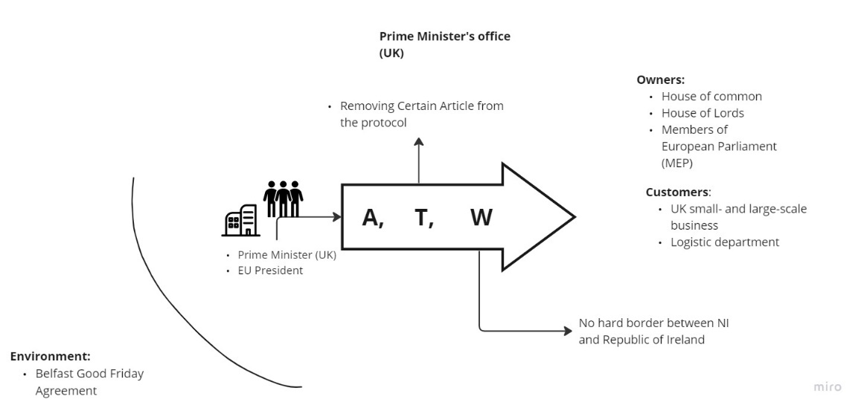

Fig 4.2(a) CATWOE for first stakeholder

**European Union President office**

**CATWOE**

**Customer:** Rest of the EU state will benefit from current deal as NI will follow EU’ customs union and tariff.

**ACTOR:** EU president and UK Prime minister will be key players again to make the important decision which can solve this conflict.

**Transformation:** - By not completely removing 5(3), Article (4) and Article (10) will protect the EU single market and level playing for rest of the EU businesses but concession on right terms will give economic stability.

**Worldview: -** Some compromised need to be done by renegotiating, to avoid trade war.

**Owners: -** Members of European Parliament, House of Common and House of Lord

**Environment: -** Any potential deal should respect Belfast good Friday agreement.

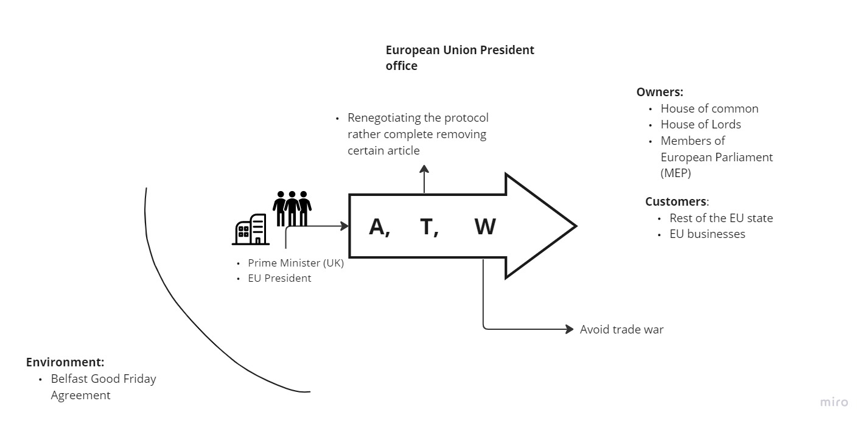  
Fig 4.2(b) CATWOE for second stakeholder

**Democratic Unionist Party (DUP)**

**CATWOE**

**Customer: -** Pro Unionist people in Norther Ireland.

**Actor: -** DUP party leaders will be key players who can take decision on whether to form a

government or not.

**Transformation: -** Negotiating with UK government to strike a deal which can benefit Northern Ireland business and its status within the United Kingdom.

**Worldview: -** In order to achieve long-term political stability and provide a peaceful and prosperous future for our people, our objective is to uphold and strengthen Northern Ireland's constitutional position within the United Kingdom.

**Owners: -** DUP leaders

**Environmental Constraint: -** Northern Ireland Protocol

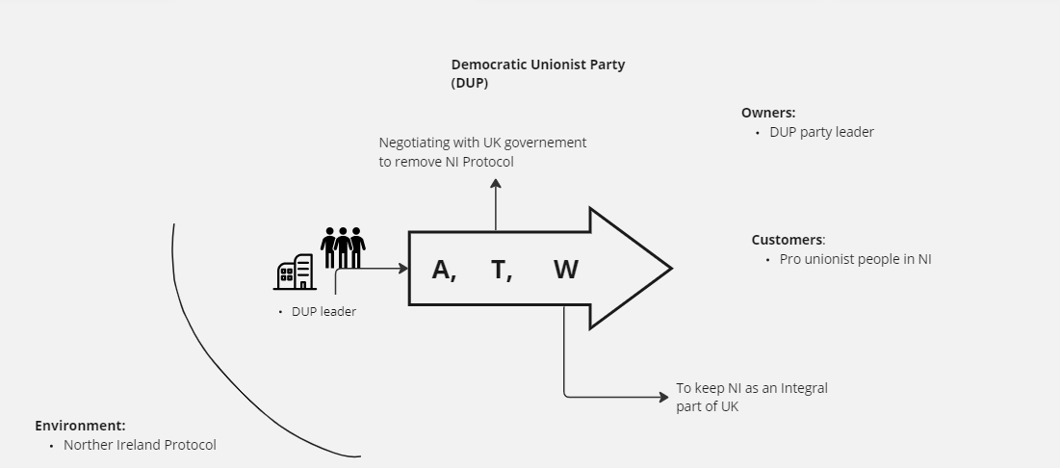

Fig 4.2(c) CATWOE for third stakeholder

**SIN Finn**

**CATWOE**

**Customer:** Sinn Fin leaders are suffering as they are not able to form the executive office and also common people.

**Actor: -** Sin Finn and DUP leaders will be key players to form the executive office

**Transformation:** By negotiating with DUP leaders and UK government to ease down the political instability and form the Executive office as early as possible who can govern the NI.

**Worldview: -** Appointment of Executive office is important for governance of Northern Ireland.

**Owner**: - Both DUP and Sin finn leaders

**Environmental Constraint**: - Consociationalism (Power-sharing) Governance

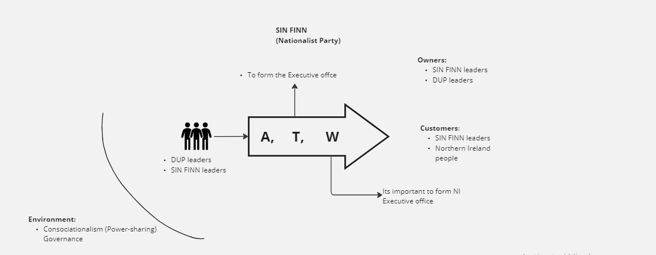

Fig 4.2(d) CATWOE forth stakeholder

## 4.3 Conceptual Model

### 4.3.1 Conflict One

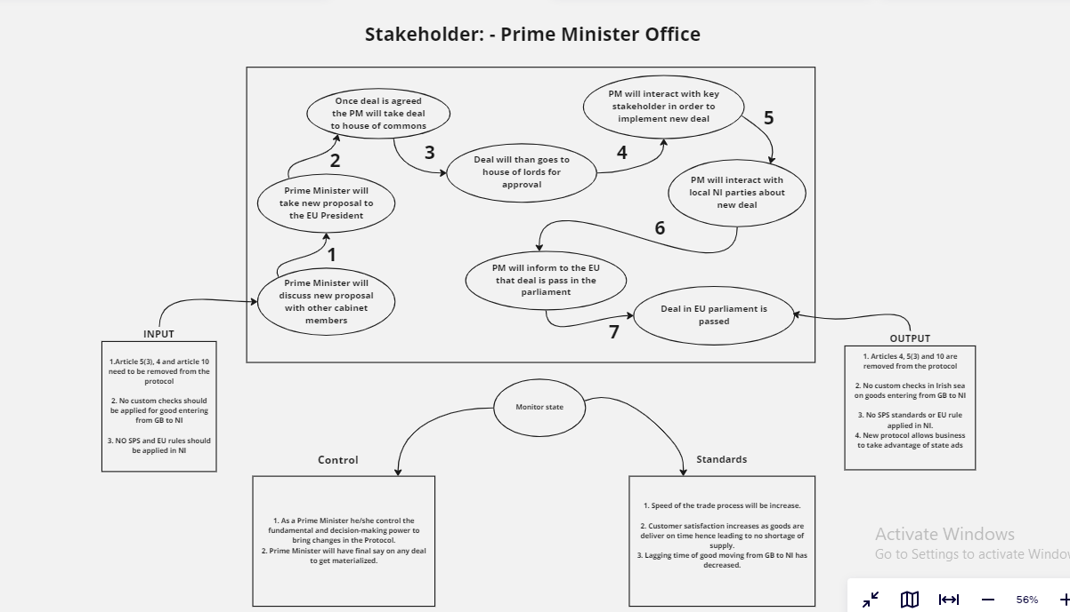

Fig 4.3.1 Conceptual Model for Prime Minister office

**E’s**

* **Efficacious** – The model is satisfying the requirement and giving the require output
* **Efficient** – The model is making most of the given resource without needing more
* **Effective –**
* **Ethical –**
* **Elegant -**

### 4.3.2 Conflict Two

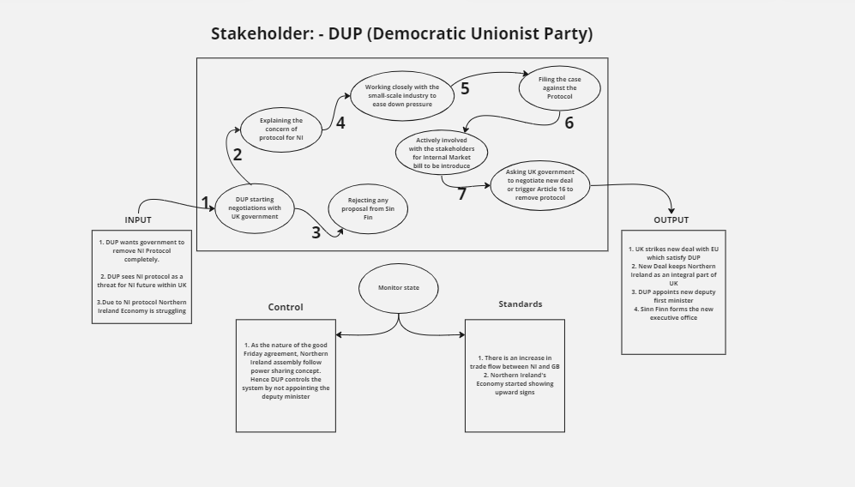

**E’s**

* **Efficacious** – The model is satisfying the requirement and giving the require output
* **Efficient** – The model is making most of the given resource without needing more
* **Effective –**
* **Ethical –**
* **Elegant -**

# 5.0 Complimentary Analysis

## 5.1 PESTEL Analysis

* **Political: -**
* The Protocol is considerably more than just a provision of the UK's withdrawal agreement with the EU; its sheer presence has important political and constitutional ramifications for Northern Ireland in the same way as its content stirs up conflicting emotions.
* Issue with the protocol is more than just goods moving from GB to NI or a Ni business not getting benefits of state aid. Its about the unionist vs nationalist
* Local Unionist party see protocol as a threat to NI’s future in UK, where as nationalist wants to keep close ties with the republic of Ireland with an intention to join unify Ireland in near future
* Above all the biggest conundrum to fix Norther Ireland protocol is 1998’s Belfast Good Friday Agreement. Any future deal has to respect the good Friday agreement.
* **Economic:** -
* War in Ukraine has already raised crude oil price to record high and two years of on and off COVID-19 lockdown has led to CPI inflation to 8.7% Q4(2022) and 8.1% is predicted for 2023(Q1)
* Delay in supply chain due to NI protocol is only making things difficult for business and Northern Ireland’s economy.
* **Social: -**
* With UK not a part of EU anymore that means freedom of movements with EU state is not available so rest of the EU this led to less EU migrants coming to UK
* For people in NI the protocol has divided unionist vs nationalist.
* **Technology**
* Regular update and maintains of the technology & server are important, as protocol says live data needs to be share on all the goods coming to Ni from GB.
* Ports need to be regularly updated with high end technology to delay the custom check process time.
* **Legal**
* Northern Ireland protocol is an International treaty signed by both UK and EU state, so any modification or removal needs to be carried out in proper negotiation manner.
* Any introduction of internal market bill will lead to legal action from the EU side.
* European Court of Justice has some power in Northern Ireland Protocol
* **Environmental**
* As protocol causing huge supply chain crisis, it is causing huge que of transport, does disturbing environment by pollution
* With regular use of Cargo ships it is also having effect to Marine pollution.

# 6.0 Recommendation

## 6.1 Propose Changes (Conflict one)

|  |  |  |
| --- | --- | --- |
| Ideal Scenario | Real World Scenario | Recommendation |
| **Prime Minister will discuss new proposal with other cabinet members** | According to the UK, the current procedure is no longer appropriate and needs to be renegotiated. | 1. Renegotiation is very much needed as it is clear that NI protocol is not working for UK and NI.  2. Only one sixth of the commodities that enter Northern Ireland are at risk of entering the EU market. Yet almost every good goes for custom checks causing supply chain crisis.  3. Article 5(3), 4, and 10 needs to be removed or replace with more sustainable solution. |
| Prime Minister will take new proposal to the EU President | At the moment talks are only carried out through intermediates and both sides are far apart on key issues like tariff on good movements and state aid, as of now new PM is yet to release his plans for Norther Ireland Protocol. | 1. Goods which are only meant to go to NI should have domestic packing but same goods which are meant to go to EU should have export marks, this will avoid the risk of goods going to EU single market.  2. Separate lane should be kept for EU goods which will follow all the required EU check and SPS standards.  3. For State aid, I recommend NI should be consider as a neutral area so both UK and EU should offer NI business a subsidiary support which means level issue of level playing goes away |
| PM will take improved deal to house of commons | Talks are still on going | 1. Since it’s a part of deal and not a complete deal it wont take long for it to clear the house of common.  2. Timing of the deal is also important as general election is not far away. |
| Deal will than goes to house of lords for approval | No new deal is on table, talks are still on going | 1. Can skip this process as it is just a part of deal and not complete new one |
| PM will interact with key stakeholder in order to implement new deal | New PM has yet to reveal the strategy and plans for Norther Ireland protocol | 1.Needs to speed up the process for negotiation as business are suffering |
| PM will interact with local NI parties about new deal | Currently talks with the local party is stagnated due no Executive office in place. | 1. It is important for PM office to involved both Sin finn and DUP party in the talks as their opinion are important. |
| PM will inform to the EU that deal is pass in the parliament | As of now no deal is agreed | 1. Do nothing |

### 6.1.1 AS IS and TO BE PROCESS MAP

* AS IS process map is nothing but current state of a process, or what is currently happening, it gives better understanding to find and actual issue.

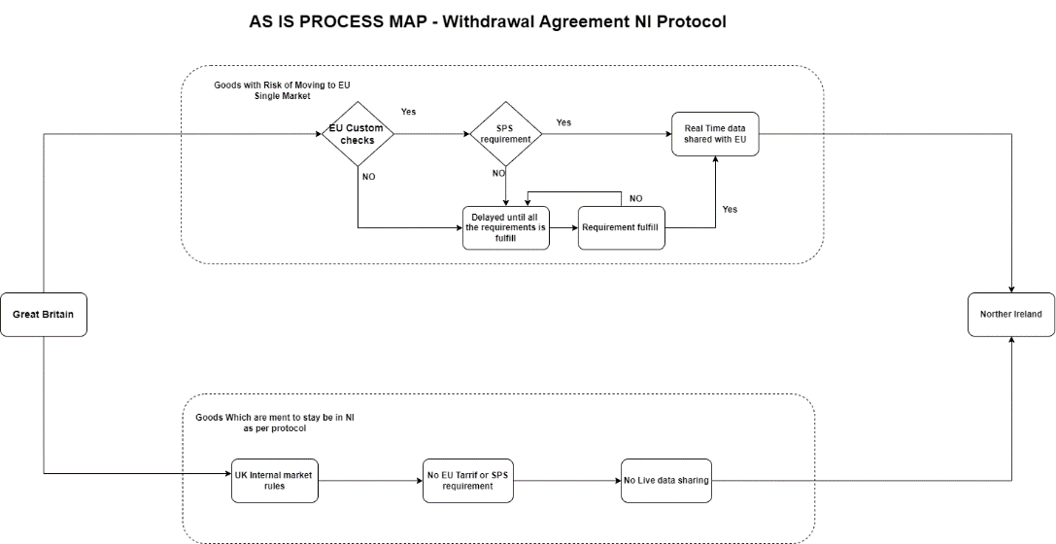

*Fig 6.1.1 AS IS PROCESS MAP for Real world scenario*

* TO BE process map is not but what process will be after bring certain or new changes.

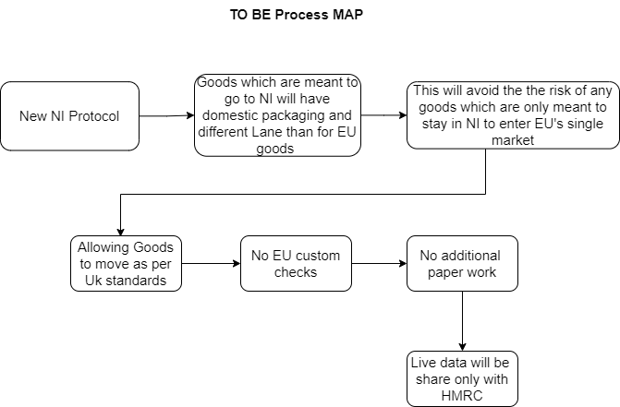

Fig 6.1.1(a) TO BE PROCESS MAP

### 6.1.2 Ease benefit metrics (Conflict One)

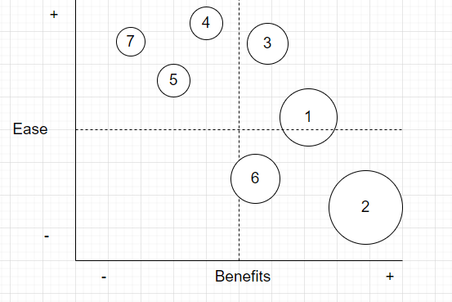

Fig 6.1.2 Ease-benefit matric for conflict one

## 6.2 Recommendation (Conflict two)

|  |  |  |
| --- | --- | --- |
| Ideal Scenario | Real World | Recommendation |
| **DUP starting negotiations with UK government** | As it stands DUP still in talks with the government but they are very clear they want Norther Ireland protocol should be completely removed | 1. DUP needs to come to a compromised, as bringing change in protocol is not solely in UK’s hand. EU are strong negotiator |
| **Explaining the concern of protocol for NI** | Talks are still going on | 1. No changes need to done |
| **Rejecting any proposal from Sin Fin** | At the moment DUP are rejecting to negotiate with Sin Finn to appoint deputy first minister, as mentioned in good Friday agreement NI assembly runs in power sharing concept so even though Sin finn is the largest party in the assembly they cannot form the government if DUP don’t appoint deputy minister | 1. It is important for DUP to appoint the deputy first minster and form the Executive office with Sinn Finn and work on day to day governance of NI.  2. In post pandemic and rising inflation it is important for people of NI to have government in place.  3. DUP should avoid reelection to add more uncertainty |
| **Working closely with the small-scale industry to ease down pressure** | Since DUP are rejecting to join the office no progress is made by them to calm the market | 1.Need to speed up the process. |
| **Filing the case against the Protocol** | High court has already rejected the DUP’s claim of NI protocol breaking Belfast good Friday agreement and Act of Unionist.  As it stands hearing is going on at Supreme Court | 1.As per my research and knowledge I believe Northern Ireland protocol respect both Good Friday agreement and Act of Unionist. Whether the protocol is good or not is altogether different story. |
| **Actively involved with the stakeholders for Internal Market bill to be introduce** | Former foreign secretary did introduce internal market bill which will unilaterally change the course of NI protocol deal | 1.Introduction of new Internal market bill will break international law.  2. UK may face legal actions from the EU side. |
| **Asking UK government to negotiate new deal or trigger Article 16 to remove protocol** | As of now government has no plan to trigger Article 16, Renegotiation is number one priority | 1. Triggering article 16 should be the last option for UK, it won’t serve the purpose as it may start a trade war with EU.  2. With raising inflation its important to avoid uncertainty. |

### 6.2.1 Ease-Benefit Matrix (Conflict Two)

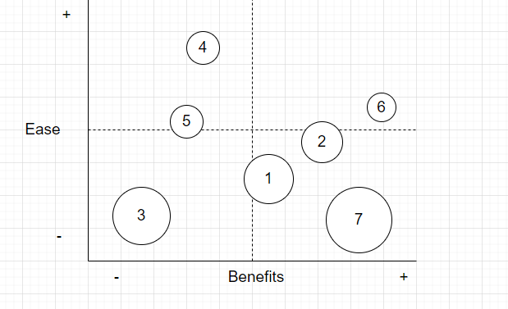

*Fig 6.2.1 Ease-Benefit Matrix*

# 7.0 Reference

https://obr.uk/forecasts-in-depth/the-economy-forecast/inflation/#rpix

<https://consoc.org.uk/the-politics-of-the-northern-ireland-protocol/>

1) https://www.economist.com/britain/2021/01/02/how-brexit-happened?utm_medium=cpc.adword.pd&utm_source=google&ppccampaignID=18156330227&ppcadID=&utm_campaign=a.22brand_pmax&utm_content=conversion.direct-response.anonymous&gclid=CjwKCAiAs8acBhA1EiwAgRFdw6wafT2veO62yNbOJue5Wu9fp4YaIlV_KNImelfiVt-eY9NyWhGqNBoCqW8QAvD_BwE&gclsrc=aw.ds

2)https://www.citizensinformation.ie/en/government_in_ireland/ireland_and_the_uk/what_is_brexit.html

3)https://www.gov.uk/government/publications/northern-ireland-protocol-the-uks-solution/northern-ireland-protocol-the-uks-solution

4)https://assets.publishing.service.gov.uk/government/uploads/system/uploads/attachment_data/file/950601/Northern_Ireland_Protocol_-_Command_Paper.pdf